Senior Catchment Modeller, PO4
Water Quality Modelling, Water Planning Science, Water and Catchments, Science
 | Role type  Flexible |  | Closing date  Friday, 27 March 2026
 | Salary  annual $118,967 to $127,941  fortnightly $4,560.00 to $4,904.00  plus 12.75% super contributions <and provision of housing> |  | Contact  Gillian McCloskey, Science Co-Leader  gillian.mccloskey@detsi.qld.gov.au  0428 114 535
 | Location  Flexible (View our locations) |  | Job ad reference  QLD/682254/26
 | Working relationships  Reports to: PO6 Science Co Leader  Direct reports: 0 / Team size: 13 |  | For more information  Visit Working with us

Purpose
As a senior member of the Paddock to Reef Catchment Modelling team, you will be developing and applying catchment water quantity and quality models for basins across the Great Barrier Reef (GBR). You will be required to interpret modelled outputs, provide input to the annual Reef Report Card and evaluate the land management activities that address reef water quality targets and outcomes. The role will support the development of state government policies and inform the prioritisation of government funding. You will be required to provide leadership, specialist technical and scientific advice to state and federal government agencies, regional NRM groups and other science professionals across the state.
The role
As the Senior Catchment Modeller, you will:
- Lead the development of catchment water quantity and quality models, for basins across the GBR, to report improvements to water quality resulting from improved land management practice adoption to support the annual Reef Report Cards.
- Represent the Queensland Government and build relationships with other stakeholders, presenting results and outputs from the modelling in a range of forums, including scientific workshops, regional body and stakeholder meetings and the production of technical reports and peer reviewed papers for scientific journals.
- Support regional bodies and industry groups to identify needs and opportunities to improve the sustainable use of land and water resources.
- Interact closely with other professionals collecting relevant data and information and liaise and collaborate with scientists and professional officers from a range of State and Commonwealth agencies, regional bodies and other institutions involved in modelling.
- Provide expert technical advice to internal and external clients on land management and reef catchment modelling outcomes.
- Provide science leadership in modelling, integrating new data and innovative approaches to improve water quality modelling.
- Other duties as directed and required.
- Promote a safe, respectful and inclusive workplace that is free from bullying, discrimination and harassment.

What we are looking for
We’re looking for the best-suited person for the role. If you are eligible, we will consider your skills, experience, qualifications and personal qualities relevant to the role. We may also consider your past work, your future contribution to our team and department and your commitment and contribution to equity, diversity, respect and inclusion.
What you need for this role  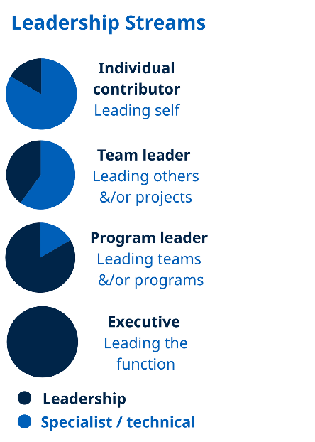 | Role model Individual Contributor leadership behaviours as outlined in the Leadership competencies for Queensland.  - Technical Expertise – Displays an in-depth knowledge of water quality modelling technology and land management practices, catchment hydrology and pollutant transport processes, systems relevant to their work to meet service delivery expectations.  - Technical Expertise - Proven experience with programming (Python preferred), ability to parameterise and execute large model runs, as well as analyse and summarise large volumes of data. Experience with GIS is desirable.  - Project Management – Establishes performance outcomes and measures for key project goals and defines monitoring, reporting and communication requirements. Monitors the completion of project milestones against goals and initiates amendments where necessary.  - Teamwork and Collaboration - Promotes teamwork and achievement by encouraging others to share information and ideas across teams.  - Communication – Produces reports and recommendations, which are evidence based, clearly argued, concise, and provide a sound basis for decision-making. Conveys ideas and information in a confident, clear and interesting manner.  - Client Engagement – Builds strong client and key stakeholder relationships.  - Demonstrate how you can support our commitment to workplace safety, equity, diversity, respect and inclusion.
Eligibility | You will need the legal right to work in Australia.  Licences  It is desirable for the occupant of this position to hold a current unrestricted driver’s licence. Employees may be required to drive government vehicles, including four-wheel drives as a part of their day-to-day and field work.  Qualifications  You must hold a degree in one of the following disciplines: Agricultural Science, Environmental Science, Engineering, Rural Science, Natural Resource Management or agreed equivalent from a recognised tertiary institution.  If your qualification is from an overseas institution, you must apply for official recognition through the Overseas Qualification Unit at the time of application and provide evidence of your application with your resume.
Additional information | The successful applicant will be subject to pre-employment checksincluding disciplinary disclosure. Once employed, additional requirementsmay apply, such as probationary period, conflict of interest declarations, and lobbyist registration.
Travel | This position may require travel to other locations from time to time, including overnight stays.

How to apply
Everyone is welcome to apply. We offer priority consideration to applicants with disability or who identify as an Aboriginal or Torres Strait Islander and have what you need for this role. Priority consideration applicants will be invited to participate in the next selection activity.
Please let us know what we can do to help you participate in the recruitment process and ensure your needs for cultural safety or workplace adjustments are considered. For more information on how-to-apply, including options for adjustments, visit Working with us.
To apply for this role, please provide us information about:
- your skills, experience, qualifications and personal qualities and how they align with the requirements in the What we are looking for section; and
- why you are the best-suited person for this role.
- You can provide these in a succinct resume (max 6 pages) and short statement (max 2 pages) or contact Gillian McCloskey to explore other options.
If your application is progressed, you will need to provide evidence of your Eligibility.

Additional selection requirements
If you are applying under the following category/categories you are required to provide additional documentation.
Aboriginal and/or Torres Strait Islander priority consideration
To enable the selection panel to confirm that you are eligible for priority consideration, the panel requires:
- your written assertion that you are of Aboriginal or Torres Strait Islander descent.

Diverse Ability priority consideration
To enable the selection panel to confirm that you are eligible for priority consideration, the panel requires:
- your written assertion that you are a person with disability.

Submitting your application
Applications will be accepted through the Smart Jobs and Careers website www.smartjobs.qld.gov.au. If you are unable to apply online please contact 13 QGOV (13 74 68) or visit How to apply | Department of the Environment, Tourism, Science and Innovation (DETSI), Queensland.
Hand-delivered applications are not accepted.

